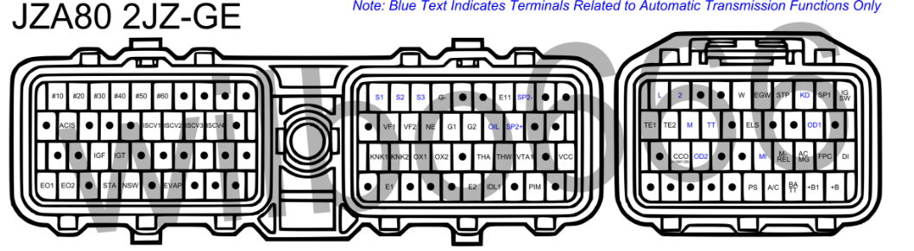

**Primary**

Fuel Pump

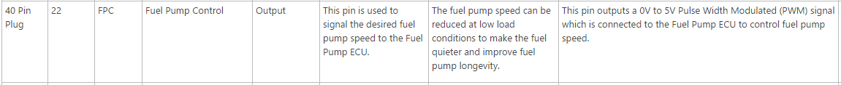

*Note: Standard FP output does not support PWM, either map an existing unused PWM output or rewire and relay 12v to FP and use standard

12V switched and ground

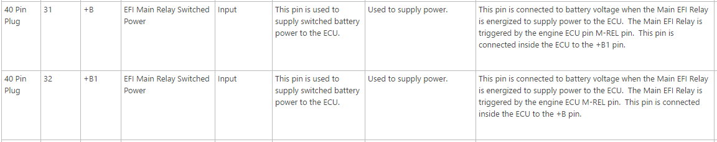

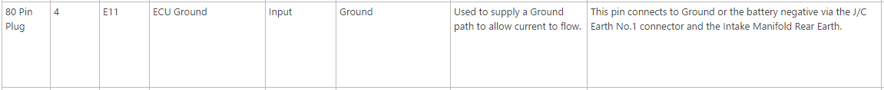

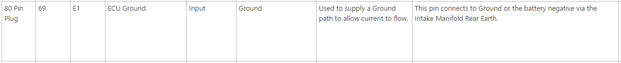

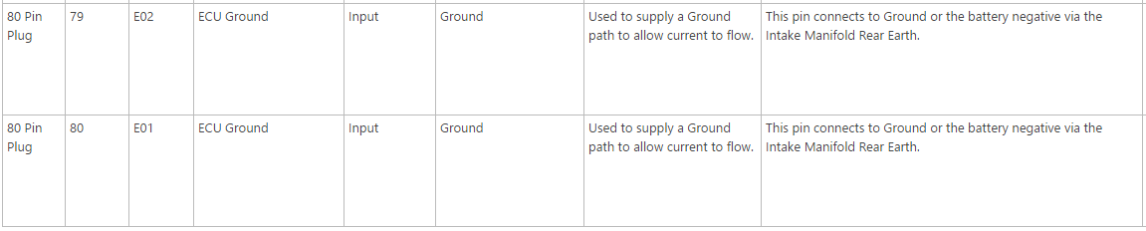

Sensor 5V

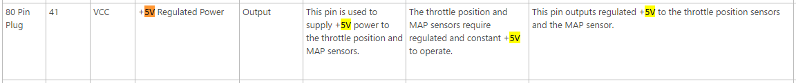

Sensor Ground

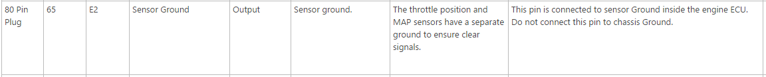

Cam & Crank

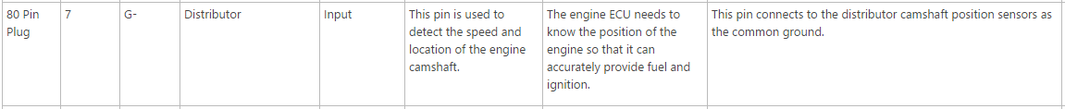

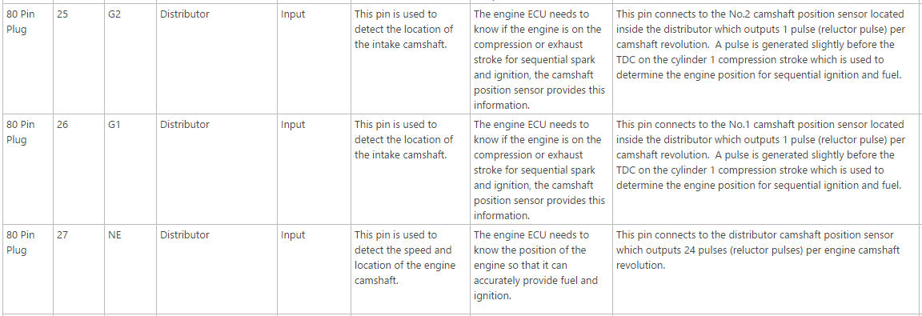

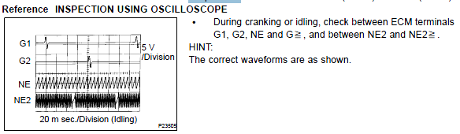

*Refer to Nathaninwa post

Injectors

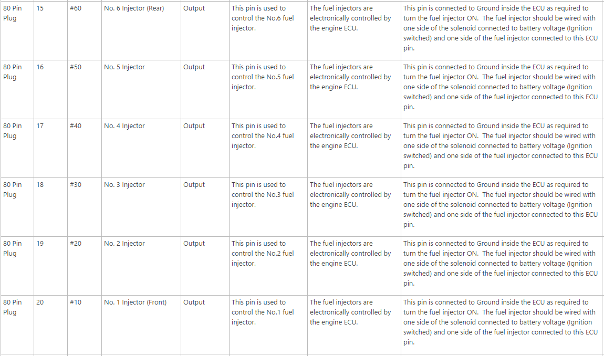

*Measure resistance first before connecting in case of low impedance

IAC

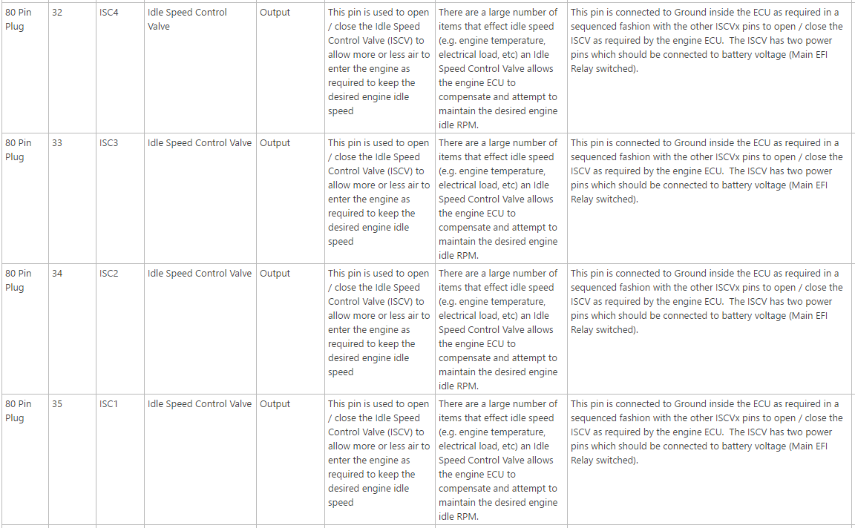

*Refer to 2jz-ge engine diagnostics.pdf to see exact signals needed

TPS

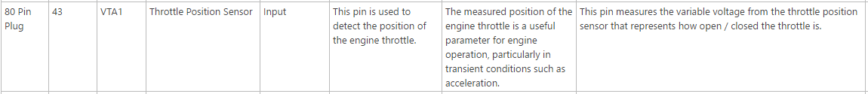

IAT

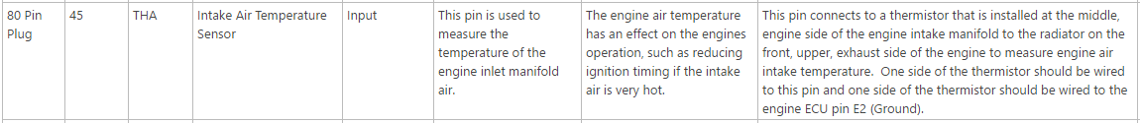

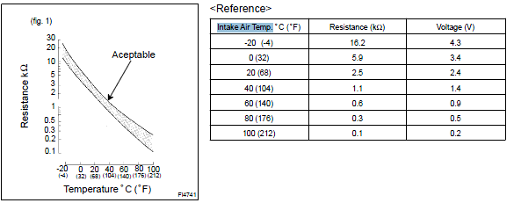

O2

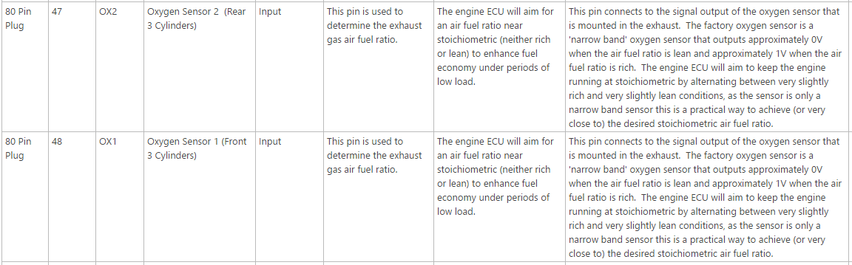

Map

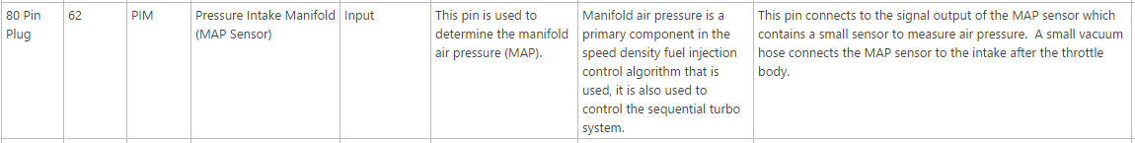

Cranking

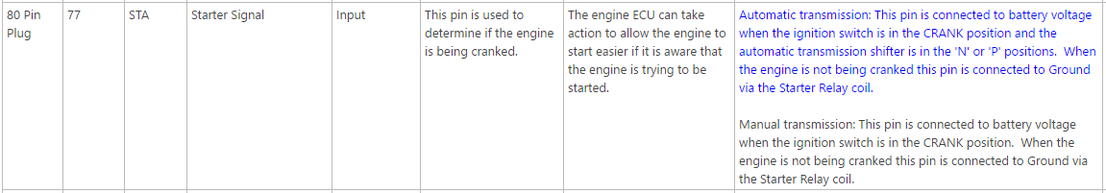

Other

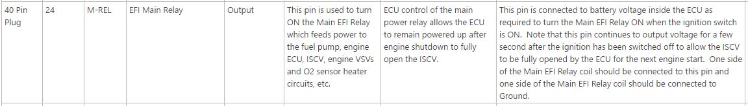

**Secondary**

Speed

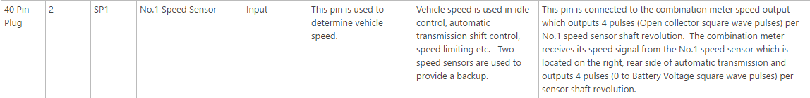

CEL

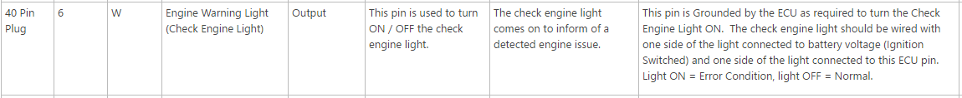

ACIS (long-shortrunners)

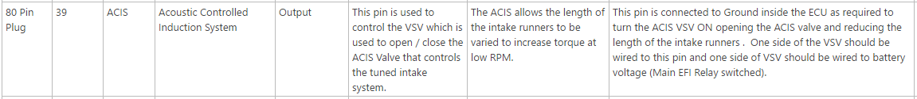

Coolant Temp (CLT)

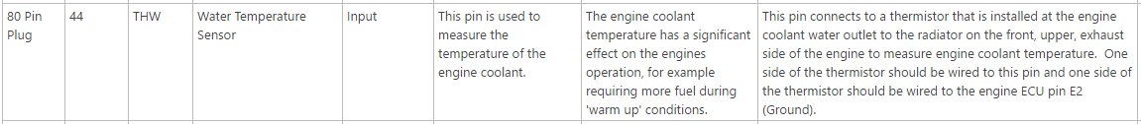



Knock

